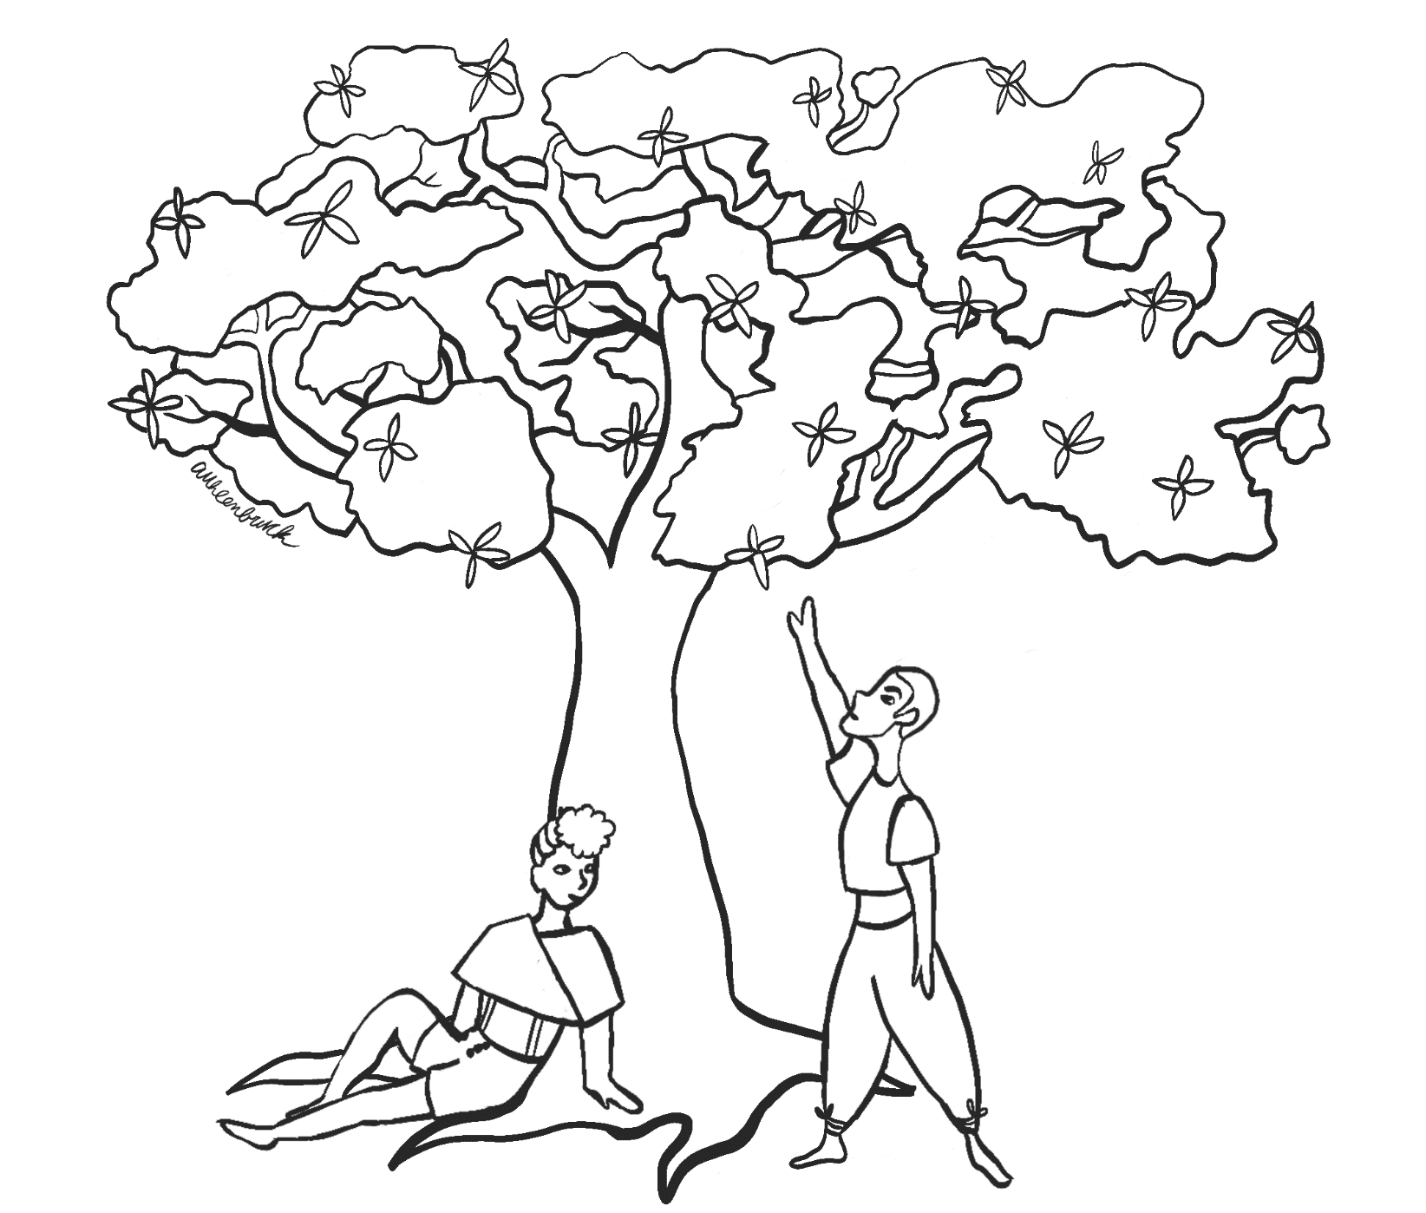

Roots & Flowers

A Solarpunk game about community and caring

A Solarpunk game about community and caringRoots & Flowers

A Solarpunk game about community and caringRoots & Flowers

A Solarpunk game about community and caring

# Attributions and Credits

Roots and Flowers is a solarpunk hack of [Lasers and Feelings](https://johnharper.itch.io/lasers-feelings) by [John Harper](https://johnharper.itch.io/).

[Roots & Flowers](https://gabrielcaetano.itch.io/maker-a-journaling-game-about-making-impossible-futures-possible)© 2021 by [Gabriel Caetano](https://gabrielcaetano.itch.io/)is is made available by Creative Commons Attribution 4.0 International [CC BY-SA 4.0 ](http://creativecommons.org/licenses/by-sa/4.0/?ref=chooser-v1).

This means you are free to share and adapt these materials in personal and commercial works provided that you use the same license type and that you give attribution to Gabriel Caetano using the following text:

Attribution

This work includes material derived from ROOTS & FLOWERS, available by CC BY-SA 4.0 license at https://gabrielcaetano.itch.io. [Product Name] is not affiliated with Gabriel Caetano.

Limitations

ROOTS & FLOWERS’s rules are intended for use in cool games. Do not include racist, sexist, homophobic, transphobic, bigoted tropes, themes, and other content in materials derived from Gabriel Caetano’s work.

## Cover Art by

Apollo Uhlenbruck

Twitter: @youknowfromtv

<http://schteeef.itch.io/>

<https://stefuhlenbruck.wixsite.com/portfolio>

## You Will Need

* This game;
* 3+ players (one will be the facilitator);
* Writing resources, analog or digital;
* At least 1 dice, analog or digital, but more are more fun;
* The intention to create futures you would want.

## You could also have

* Modules and extra rules
* Snacks and beverages
* A strong desire to take down capitalism and all forms of oppression, bigotry and environmental destruction.

Contents

Attributions and Credits 2

Playing Safe Games 4

Roots & Flowers 11

Leave Feedback 26

# Playing Safe Games

When you play ROOTS & FLOWERS, or any other game, remember to be kind to yourself and to the other players. Use these tools or any others you like to ensure a safer game for everyone.

## Before Play: [CATS](https://200wordrpg.github.io/2016/supplement/2016/04/12/CATS.html)

This is a tool to make sure everyone has a say in what kind of adventure they want to play, and to determine whether this game or adventure really is for you or if you should play something else, or join a different group. It has four prompts:

Concept

At a high-level, what’s this game about? Are there conditions for success? What kind of adventure can we have with it? Are the rules light or deeper?

Aim

Discuss what kind of stories you would like to tell. What would we like to accomplish? How much social interaction, exploration, drama, or action would we like to have?

Tone

Find consensus about what kind of game everyone wants to have: Is the atmosphere more light-hearted, humorous, dramatic, intense? A combination of those?

Subject Matter

What ideas do we want to explore during gameplay? Do they make anyone uncomfortable? Discuss what boundaries need to be set, if any, and how to handle triggers, uncomfortable subjects and safety at the game.

## During Play: from [Wanderhome, by Jay Dragon](https://possumcreekgames.itch.io/wanderhome)

These are a few prompt and questions players can use during their adventure.

“Let’s do this instead.” – When the chose course of action is making someone uncomfortable, choose a different one.

“Do we want to?” – When you’re not sure everyone is onboard with the chosen course of action you chose, this is a way to express that you’d like everyone to buy in.

“Where to next?” – If you feel the adventure came to a stand still or that you are stuck, you can discuss what to do to move the adventure forward.

“What do you think?” – Sometimes we need a bit of extra time to think, focus or express ourselves. If someone seems quieter or seems to be speaking less, you can ask them what they think and chack how they are feeling.

“Hold on.” – Sometimes we need a break for some water and self-care, or because something happened that is making us uncomfortable and we want to tackle it, or because we want to look back at something from earlier.

“No.” – You shouldn’t do something you don’t want to. If you feel you need to change something to fit your needs or to have agency over your character or the world around you.

Step away – The base assumption is that the game is being productive and that issues and problems can be navigated safely through conversation. If that’s not the case you can leave at any moment.

## After Play: [Stars and Wishes](https://www.gauntlet-rpg.com/blog/stars-and-wishes), from The Gauntlet

At the conclusion of a game session everyone who played, including the facilitator, offers a Star to another player, to a moment in the game, or to an element of the overall experience (you can give out more stars if you have time). You can award a star for - amazing roleplay, great character moments, amazing descriptions by the GM, the feeling you had at a certain moment, another player’s generosity, a mechanic of the game system that really sang etc. A star is a thing you loved about the game - if the game you played was amazing it is often hard to choose!

After stars have been given, everyone makes a Wish. Each player tells the table something they would like to see happen in a future session. You can make a wish about: something you want to see happen with your own character, an interaction you’d love to see between two characters, a mechanic you would like to see come into play that you haven’t seen yet, places you hope the story might go, etc.

## Debrief: [EARS](https://blackarmada.com/tools-to-use-after-play/), from The Gauntlet

This is a structured way for everyone to talk about the game you just played, and to learn about how everyone is feeling, as well as giving yourself the opportunity to relax and come out of character. It has four prompts.

Explain

Discuss what the debrief will cover. (I suggest including: talking about everything that happened, discussing any highlights, addressing any challenging issues that came up in play, talking about how it made us feel, talking about anything we learned.) It’s possible this is going to be mostly enthusiastic reminiscing, but it could be that someone has had a bad time and wants to talk about it. So, encourage everyone to be ready to listen supportively.

Agenda

Give everyone the opportunity to name one thing they’d like to talk about, and briefly say why (no big deal if it turns out to be two things, and no big deal if some people don’t have anything they want to talk about.)

Reflect

Let each person talk through their one thing in their own words, without interruption. What moment(s) from play are they speaking to? Was there anything in particular they wanted to address in discussion? Why did they want to focus on this?

Support

Everyone else is free to respond, but in a supportive way. If you don’t agree with what they said, that’s fine, but try not to make it personal, or make them feel like their opinion isn’t valid. Even if you don’t agree, make sure you listen and try to think about what you can learn from this. Ask clarifying questions and provide your own thoughts and reflections.

## Conclusion

You may find these and safety tools more in this [List of Safety Tools](https://gabrielcaetano.itch.io/safety-tools-and-wellbeing-a-curated-list).

Feel free to adapt these to your group and your game needs.

# Roots & Flowers

In a not-so-distant future, we gave up the illusion of knowing better. This opened new avenues in technological innovation, improving life, and opening our awareness of the subtle, ancestral magic of the world.

You are the local community's troubleshooters. Your community turns to you for aid in things big and small. You resolve them by means of innovation, knowledge, technology, mediation, and ancestral guidance.

**Player Goals:**

* aid and support your community;
* go on wild, fun, solarpunk adventures;
* imagine a possible future.

## The World Before

Much has changed after what is collectively known as the World Before, a time before civilisation turned away from a global culture of colonisation, destruction and environmental chaos, complete disregard for life, human or otherwise, and cannibalistic individualism.

It was not easy, people changed, civilisation changed, and humans sought to repair the damage caused to the planet. Most of that exists only as ruin or relics, called The Legacy.

While technology advanced at an incredible rate, specially as collective efforts turned towards health, sustainability and efficient means of generation and consumption of energy, not all damage was healed. After all, if you break a pot and glue it back, it will still retain the cracks from its fall.

This is an age of exploration – the exploration of self, identity, and gender, of the relations between humanity and its more-than human counterpart called Nature, of what it means to be a community, and of the endless possibilities of futures we want.

## The Legacy

Relics from the World Before, technology, records, buildings, structures, as well as all damage caused, all of that is simply referred to as The Legacy. Most of The Legacy has been recycled, repurposed and redesigned over time, but in some places, the Wild has never quite recovered, and some things are, to this day, way too dangerous to approach.

Remnants of the legacy are found in contemporary life, quirky things to play around with.

In adventures about The Legacy, players may choose to encounter things they wish to get back at, such as war things and other tools of suffering and oppression. This is a chance to reawaken them, so they can unmake them once for all, or see any other end they desire.

## Ancestry

Old recipes from someone's gran gran, the elderly of the community, the stories untold by the land itself or the millenia-old cultures and traditions brought forth from indigenous peoples, are all forms in which Ancestry manifests. And there is a subtle, gentle magic that comes from it.

Ancestry allows players to express their own connection with the past and how it guides and shapes their future.

In adventures around Ancestry, the players may explore how traditions survive, how we relate to the elderly and how we use this knowledge to look forward. Players may also explore their own ancestral roots to indigenous peoples and nations, and explore how they thrive and inspire the community.

## Magic

Ancestral Magic is subtle, kindly and accessible to all. A stew made to cure a cold could be infused with magic through reverence of passed down cooking recipies. An explorer could feel how the Wild around whispers to all of those who allow themselves to listen, and find paths before unknown. A Teacher could turn their teaching grounds into a magical place of connection and empathy through careful preparation and attention to those who come to attend.

When expressing Ancestral Magic, tell the other players how it manifests and ask the others whether it wants to manifest then and there, and what it will do.

It cannot miraculously cure a wound or lift a boulder, but it can show things hidden, soothe someone's suffering or aid in unobtrusive, gentle ways.

## Create a Character

1. Choose a role for your character:
   * Mediator
   * Rebel
   * Caregiver
   * Engineer
   * Architect
   * Artist
   * Explorer
   * Teacher
2. Choose a trait for your character:
   * Kind
   * Resourceful
   * Contemplative
   * Creative
   * Generous
   * Co-operative
   * Savvy
   * Crafty
   * Mystic
3. **Choose your number, from 2 to 5. A high number means you're better at FLOWERS** (insight, lightness; compassion; forgiveness; balance; boundaries; subtle, subjective care; magic sense).

**A low number means you’re better at ROOTS** (presence; consciousness; practical, objective things; drive; focus; movement; magic expression).

1. **Give your character pronouns (or not) and a name** that represents them, that they picked because is meaningful for them, or that is just punk (or all the above).
2. **Choose a Goal:** 
   * Accessibility (make stuff accessible to all);
   * Inclusivity (make sure everyone is represented);
   * Change (occupy or unmake spaces to make them better for all);
   * Knowledge (teach and learn, to make informed choices);
   * Ancestrality (be in touch with your ancestors and their bottomless wisdom);
   * Sustainability (optimise the use and management of resources);
   * Joy (spread beauty, happiness and reflection through graffiti, music, theatre or any other form of art);
   * Biodiversity (explore ways to integrate human life into nature and vice-versa).
3. **Choose a special gadget:** a portable super computer; a multimedia 3d projector; an advanced toolkit; a MedPAC; a universal analyser; a vibro-cutter; a small AI drone.
4. Complete the sentence below with the information you chose. Sprinkle in as much detail and personality as you feel like.

**My name is [name, pronouns]. I am a [trait] [role]. I want to [goal].**

**You also have:** a satchel, bag or backpack, a bit of food, a comm device with a camera and Net access, and your favourite outfit.

## Example Character: Beam

My name is **Beam** (Xe/Xem). I am a **Kind** **Mediator**. I want to be in touch with my ancestors and their bottomless wisdom.

I have a small AI drone, as well as a satchel, a bit of food, a comm device with a camera and Net access, and my favourite hat.

Roots & Flowers 4

## Create a Community

As a group choose two characteristics of the community you live in: close-knit, self-sufficient, plenty of natural resources, spacious, a great learning center, a great community center, ancestral guidance, diverse means of communication, accessible architecture, a culture of proactivity.

Choose one challenge the community faces: great distances, unbalanced resource management, isolation, environmental legacy, poor infrastructure.

Give your community a name.

## Example Community

The Baobab Community is Close-knit and boasts a culture of proactivity.

Our biggest challenge is the environmental legacy from the World Before.

## Roll the Dice

When you do something challenging, uncertain, or bold, roll 1d6 to find out how it goes. Also:

* If your role applies to the roll, roll +1d6.
* If your trait applies to the roll, roll +1d6.
* If your character goal aligns with your course of action, roll +1d6.
* If you have appropriate equipment for the task, roll +1d6.
* If you act upon an answer you got from a WILD roll, add +1d6.

When you roll your dice, compare each die result to your number.

**If you’re using FLOWERS** (sensibility, soft approaches, inner magic), you want to roll under your number.

**If you’re using ROOTS** (drive, direct approaches, expression magic), you want to roll over your number.

**Hit: 3+** dice succeed. You describe how your action was effective or successful. It reveals an unforeseen benefit or extra effect.

**Success:** 2 dice succeed. Describe how your action was successful or effective.

**Good Effort:** 1 dice succeeds. Describe how your action was only partly successful or effective.

**Miss:** No dice succeeds. Your attempt is uneffective or you are unable to succeed. Describe how things went wrong and add a complication.

**Call of the WILD:** you roll exactly your number. You heed the Call of the Wild, getting special insight into what’s going on. Ask the GM a question and they’ll answer you honestly.

Some good questions:

* What are they really feeling?
* Who’s upset about this?
* How could I help them to _?
* Whose perspective is not represented in the room?
* What should I be on the lookout for?
* What’s the best way to _?
* What’s really going on here?
* What do my ancestors say about it?

## Facilitate the Game

Play to find out how to help the community overcome its challenges.

Introduce a new issue by hinting at what sort of problems it is causing.

Show signs of trouble before it breaks out and when it's about to happen, then ask the characters what they do.

"There's been a perceptible shift in the population and placement of a lot of insect life lately. What do you do?”

"Your PAD has been acting up over the past couple of days - everyone's PADs have, as a matter of fact. What do you do?”

Call for a roll when a situation is challenging. Don’t pre-plan outcomes—let things happen. Use shortcomings to drive the narrative. The situation always changes after a roll, for good or ill.

Ask questions and build on the answers. "How much do you know about the World Before?”

## Solarpunk Adventures

Roll or choose on the tables below.

|  |  |
| --- | --- |
| There is/are | Is/are causing |
| 1 Conflicting approaches  2 A huge storm  3 An out-of-date management system  4 Stubbornness  5 Animal migration  6 An unearthed nuclear plant | 1 Isolation  2 Damage  3 Harm  4 Endangerment  5 Hinderance  6 Disturbance |
| To | And is/are going to |
| 1 The Learning Center  2 Solar Panel Network  3 Many native species  4 The algae and renewal hyper-farms  5 Community balance and closeness  6 Job assignment board systems | 1 Make the water sources inviable  2 Cause a huge power shortage  3 Make everyone sick or hurt  4 Greatly unbalance in the local biomes  5 Force some folks to evacuate their homes  6 Create a rift among the people |

## Example

Conflicting approaches are causing harm to the community balance and closeness and is going to create a rift among the people..

# Leave Feedback

Leave some feedback about ROOTS & FLOWERS. Here are a few topics:

* Do you want to share your experience in a session you played this game?
* Is there something specific you enjoyed?
* Is there any harmful content I should change or remove immediately?
* Is there something you’d like to get more of in regards to rules or the setting?
* Was the game fulfilling and fun for you and your group?

You may leave a review at [this game’s Itch Page,](https://gabrielcaetano.itch.io/roots-and-flowers) or contact me over [Twitter](https://twitter.com/TheGiftOfGabes) or email: [gabriel_caetano@live.com](mailto:gabriel_caetano@live.com).